Appendix XX.
NATURAL Background Visibility Conditions
Considerations and Proposed Approach to the calculation of Natural Background Visibility Conditions at MANE-VU Class I areas

Natural Background Visibility Conditions

1. Introduction
The long-term visibility conditions that would exist in absence of human-caused impairment are referred to as natural background visibility conditions. Accurate assessment of these conditions is important due to their role in determining the uniform rate of progress that must be considered when setting reasonable progress goals for each mandatory Federal Class I area subject to the Regional Haze Rule. Baseline visibility conditions – based on monitored visibility during the five year baseline period (2000-2004) – and estimated natural background visibility conditions will determine the uniform rate of progress to be considered when setting reasonable progress goals for any Class I site.
The U.S. Environmental Protection Agency (EPA) issued draft methodological guidelines for the calculation of natural background and baseline visibility conditions at each site as well as methods for tracking progress relative to the uniform rate of progress that these values determine. This draft guidance, issued in September 2001 was subsequently finalized in September 2003. The final guidance recommends a default method and allows for certain refinements that states may wish to pursue in order to make these estimates more representative of a specific Class I area that may be poorly represented by the default method.
This appendix provides a description of the default method for calculation of natural background conditions. In addition, the default method is applied to each Class I area in or near the MANE-VU region in order to establish default natural background conditions on the twenty percent best and worst days. A discussion of potential refinements to the default method is presented along with rationale for their consideration. The uncertainty associated with each potential refinement is then considered in the context of the overall uncertainty of the default estimates. Finally, a recommendation for estimating natural visibility conditions to be included in this SIP is provided.
Based upon these analyses, as well as comments received on the draft MANE-VU proposal, it appears that while some aspects of the default calculation method are understood well enough that they could be considered as potential refinements, MANE-VU does not feel these refinements are warranted in light of the very large uncertainties associated with the most basic elements of the default estimates (naturally occurring ambient concentrations). The identified refinements would result in substantial differences relative to default estimates without significantly improving the accuracy of our estimate relative to the default. Rather, MANE-VU advocates a proposed approach that is based on use of the default estimates while a program of research is undertaken to refine those elements which are most uncertain (natural concentrations) in order to reduce the overall uncertainty as better scientific understanding of these issues evolves. Refinements to other aspects of the default method (e.g. refinements to the assumed distribution or treatment of Rayleigh extinction, inclusion of sea salt, and improved assumptions about the chemical composition of the organic fraction) may be warranted prior to submissions of SIPs depending on the degree to which scientific consensus is formed around a specific approach and will be reconsidered at a later point.

2. The Default Method
The default method is explained in detail in Estimating Natural Background Visibility Conditions (U.S.EPA, 2003). Summary information is provided here but the reader should consult the original guidance documents for any question as to how this method is applied.
Estimates of natural visibility impairment due to fine and coarse particles were derived using the 1990 National Acid Precipitation Assessment Program reported average ambient concentrations of naturally present particles (Trijonis, 1990). Separate concentration values were given for the Eastern and Western United States, no finer spatial resolution is available. Average natural background light extinction due to particles was then calculated using the IMPROVE methodology and site specific ANNUAL f(RH) values. Worst visibility levels are derived using the work of Ames and Malm (2001), who estimated the standard deviation of visibility in deciviews in the eastern US as 3 dv. By assuming a roughly normal distribution of data, the default method adds (subtracts) 1.28*(3 dv) to the average estimated natural background to calculate the 90th (10th) percentile level which is taken by EPA to be representative of the mean of the twenty percent worst (best) conditions.
Thus in the East, the default method for calculating best and worst natural background visibility conditions (in deciviews) for any area in the Eastern U.S. would use the following formulae:
P90 = HI +1.28 sd
P10 = HI – 1.28 sd
Where The Haze Index (HI) represents annual average visibility in units of deciview and sd is the standard deviation of daily average visibility values throughout a year, defined by the guidance as 3.0 for the Eastern U.S. The Haze Index is calculated as shown:
HI =10 ln (bext/10)
where the atmospheric extinction, bext, is given by the familiar IMPROVE equation (IMPROVE, 2000) in inverse megameters:

Table 1. Default Parameters Used in Calculating Natural Background Visibility for Sites in the Eastern U.S.

Parameter | Value | Fractional Uncertainty | Reference/Comments
[SULFATE] | 0.23 µg/m³ | 200% | Trijonis, 1990
[NITRATE] | 0.10 µg/m³ | 200% | Trijonis, 1990
[OC] | 1.0 µg/m³ | 200% | Trijonis, 1990
[LAC] | 0.02 µg/m³ | 250% | Trijonis, 1990
[SOIL] | 0.50 µg/m³ | 200% | Trijonis, 1990
[CM] | 3.0 µg/m³ | 200% | Trijonis, 1990
f(RH) | ~3.2 | 15% | Varies by site (see Table 2)
Organic multiplier | 1.4 | 50% | [OCM]=1.4*[OC]
σ_{S/N} | 3.0 m²/g | 33% | Hegg, 1997; IMPROVE, 2000; Malm, 2000
σ_{OC} | 4.0 m²/g | 30% | Hegg 1997; Trijonis 1990
σ_{EC} | 10.0 m²/g | 40% | Malm, 1996
σ_{soil} | 1.0 m²/g | 25% | Trijonis, 1990
σ_{coarse} | 0.6 m²/g | 33% | IMPROVE, 2000
Rayleigh | 10 Mm⁻¹ | 20 % | Varies with altitude/season
sd (standard deviation of daily visibility) | 3.0 dv | 16% | Ames and Malm, 2001
10th, 90th percentile adjustment | 1.28 | 15% | Regulation calls for mean of top twenty percent, not 90th percentile
Parameters used in potential refinements
[NaCl] | ~0.5 | 50% | Varies by site, IMPROVE
σ_{NaCl} | 2.5 m²/s | 16% | Haywood, 1999
f(RH)_{NaCl} | ~3.2 | 33% | Assumed same as S, N
Note: the mass estimates presented above are based are on estimates of fine particulate concentrations that would exist in absence of any manmade pollution (including Mexican and Canadian emissions) consistent with planning requirements of the regional haze rule. MANE-VU accepts this as an appropriate planning goal and intends to consider the contribution of international transport in deciding what controls are “reasonable” under the regional haze program.

bext = (3)f(RH)[sulfate] + (3)f(RH)[nitrate] + (4)[OMC] + (10)[LAC] +
(1)[SOIL] + (0.6)[CM] + 10
Thus with respect to potential refinements to the default method, three primary approaches can be considered: refinements to the mass estimates (including spatial and temporal allocation as well as addition of other important species), refinement to the relative humidity adjustment factors (including averaging times and addition of adjustment factors for species assumed to be non-hydroscopic), and refinement to the assumed distribution of visibility conditions throughout the year (including the width, amplitude and potentially shape of the distribution). Potential refinements are considered in section 4.
Table 1 below provides the default values to be applied at all Eastern U.S. Class I areas. The result of using these default values in the above equation with an assumed annual average f(RH) value of 3.17 (the average of 11 Northeastern U.S. sites) default estimated visibility in the Northeastern U.S. is approximately 3.6 dv on the twenty percent best days and 11.3 dv on the twenty percent worst days.

3. Application of the Default Method
The Class I areas in the MANE-VU region that are subject to the requirements of the regional haze rule are: Acadia National Park, Maine; Brigantine Wilderness (within the Edwin B. Forsythe National Wildlife Refuge), New Jersey; Great Gulf Wilderness, New Hampshire; Lye Brook Wilderness, Vermont; Moosehorn Wilderness (within the Moosehorn National Wildlife Refuge), Maine; Presidential Range – Dry River Wilderness, New Hampshire; and Roosevelt Campobello International Park, New Brunswick. In addition to these Class I areas, we consider several nearby Class I areas where MANE-VU states may be contributing to visibility impairment. These Class I areas include: Dolly Sods Wilderness and the Otter Creek Wilderness in West Virginia as well as Shenandoah National Park and the James River Face Wilderness in Virginia. MANE-VU understands that it is the responsibility of the appropriate VISTAS states to establish estimates of natural visibility conditions and reasonable progress goals for these areas. It is anticipated, however that subsequent consultations will occur with those MANE-VU states which may be affecting visibility in these areas. MANE-VU has therefore calculated estimates of natural background visibility conditions at the nearby sites using MANE-VU approved methods in order to facilitate future consultations.
The only factor in the default method that varies by site is the climatological annual mean relative humidity adjustment factor. Table 2 lists this value for the Class I sites of interest and the resulting best 20 percent and worst 20 percent estimates of natural visibility conditions. The variation among sites using the default method is purely a function of differences in climatological annual mean relative humidity, with southern and coastal sites being more humid than inland or elevated sites.
Table 2. Site Specific Relative Humidity Adjustment Factors, Best and Worst (Default) Estimates of Natural Background Visibility Conditions

MANE-VU Mandatory Federal Class I Area | F(RH) | Best Visibility  (dv) | Worst Visibility  (dv)
Maine
Acadia National Park | 3.34 | 3.77 | 11.45
Moosehorn Wilderness | 3.15 | 3.68 | 11.36
Roosevelt Campobello International Park, New Brunswick | 3.16 | 3.68 | 11.37
New Hampshire
Great Gulf Wilderness | 3.01 | 3.63 | 11.30
Presidential Range – Dry River Wilderness | 3.02 | 3.65 | 11.30
New Jersey
Brigantine Wilderness | 2.97 | 3.60 | 11.28
Vermont
Lye Brook Wilderness | 2.91 | 3.57 | 11.25
Nearby Mandatory Federal Class I Area
Virginia
James River Face Wilderness | 2.93 | 3.56 | 11.26
Shenandoah National Park | 2.95 | 3.57 | 11.27
West Virginia
Dolly Sods Wilderness | 3.06 | 3.64 | 11.32
Otter Creek Wilderness | 3.06 | 3.65 | 11.32

4. Potential Refinements
According to the guidance (U.S. EPA, 2003), “… the default approach to estimating natural visibility conditions presented in this document is adequate for the development of progress goals for the first implementation period under the regional haze rule.” However, the guidance does leave the door open for individual states or RPOs to adopt their own methods for calculating natural background if they can demonstrate that the change from the default represents a significant refinement that better characterizes natural visibility conditions at a specific Class I site.
The five Regional Planning Organizations have identified a number of areas for potential improvement and have hired a contractor to refine the understanding of natural background levels of particulates. The statement of work for this project (managed by the WRAP) includes the following text: “There are three broadly different ways to refine the default natural aerosol concentrations that are briefly discussed in the guidance document. The default annual estimates of species concentrations for the best and worst 20% haze conditions can be replaced by better annual estimates, by seasonally varying estimates, or by event-specific estimates (e.g. in the case of forest fire and dust storm impacts). Any technically defensible combination of these different ways to refine the natural aerosol concentration is acceptable. It is likely that refinement will be a multi-step process over a period of many years as the information required to justify changes are developed and reviewed.” The three methods of refinement noted in this statement of work, mirror those listed in the guidance, however, the guidance also states that, “states may identify other[ refined approaches] that are more appropriate to their own situations.”
As noted in section 2, in addition to different ways to adjust ambient concentration estimates, the relative humidity adjustment factor and the shape of the distribution would also affect the resulting estimates of naturally occurring visibility. The VISTAS RPO has commissioned a consultant to investigate potential refinements to natural background (Tombach, 2003). In addition, a white paper developed by EPRI on this topic and a recent presentation by Bill Malm of CIRA (a principal investigator of the IMPROVE program) all serve to inform the multitude of ways that calculations for natural background conditions could be refined (Malm, 2004; Kumar, 2004). A synopsis of several potential refinements and the rationale for their consideration are presented here. For more detailed discussion of the scientific merit of each potential refinement, the original references cited above (or those contained in the brief explanations below) should be consulted.
- Increase the value of the organic multiplier
The estimates of organic carbon mass that are used in the guidance are derived from Trijonis (1990), however his original estimate (1.5) has been adjusted to be consistent with the ratio of organic carbon mass/organic carbon that is used in the IMPROVE program. This value, 1.4, is uncertain and several review articles and studies (Watson 2002, Turpin and Lim 2001, Malm 2004) have suggested higher values between 1.8 and 2.1 are more appropriate values. If a higher value were to be used for the organic carbon multiplier, the estimate of natural background organic carbon mass would be similarly affected since the original Trijonis estimate was based on organic carbon, [OC], and a multiplicative factor which relates [OC] to organic carbon mass, [OCM].
- Adjust the factor used to translate average visibility conditions into twenty percent worst or best conditions
The guidance recommendation for calculating the twenty percent worst and best visibility conditions by multiplying the average by 1.28 times the standard deviation of 3.0 assumes a normal distribution and is designed to return the 90th percentile value in that distribution. The Regional Haze Rule requires improvement on the average of the twenty percent worst days. This value is not equivalent to the 90th percentile of a normal distribution. The 92nd percentile is closer to the simple average of the top twenty percent of values, if you assume a normal distribution (Lowenthal et al., 2003). In this case, a factor of 1.40 is more appropriate for calculation of the 92nd percentile, or the mean of the top twenty percent of values. However, it is clear that the distributions of visibility conditions at most Class I sites are not perfectly normal. In fact, the 90th percentile may be closer to the average of the top twenty percent of visibility conditions at sites that do not experience as many extreme visibility conditions as a normal distribution would predict (Malm, 2004).
- Account for visibility impairment due to sea salt at coastal sites
Many Class I sites are located along the coast and are significantly affected by coarse mode sea salt particles. The tail of the coarse mode sea salt particle size distribution is within the sub-2.5 micron size fraction and should properly be included the IMPROVE equation. This would be a straightforward refinement if we assume that all sea salt is in the form of sodium chloride (NaCl). However, significant evidence suggests that a substantial portion of the sodium along the Gulf Coast is associated with sodium nitrate (NaNO₃) (Malm, 2004). As sea salt particles age, atmospheric chemical processes appear to replace chloride with other ions, altering both the chemical composition and the scattering efficiency.
- Account for hygroscopicity of sea salt
Research to date reflects a substantial degree of uncertainty regarding the appropriate scattering efficiency and hygroscopic growth of sea salt particles. Refined estimates hold the potential to significantly change natural background estimates depending on assumed composition and concentrations.
- Account for organic PM of oceanic origin
Observational evidence exists to support the hypothesis that significant levels of organic precursor gases are emitted over the open ocean which could potentially increase the natural background levels of organics, particularly at coastal sites.
- Review soil concentrations
Tombach (2003) suggests that fine soil contributions in the Southeast U.S. are underpredicted by the Trijonis estimate of 0.5 ug/m3. He bases this on the estimated impact of Saharan dust and Asian dust that are subject to inter-continental transport. The contribution of these sources to Northeast and Mid-Atlantic sites is estimated to be significantly less than for Southeast and Western U.S.
- Account for episodic inter-continental dust contributions
In addition to contributing on an annual average basis, the Saharan and Asian dust impacts are likely to be highly variable in time and should not necessarily be applied on an annual average basis. Given the extreme uncertainty in predicting the frequency of occurrence at any specific site, there is no reliable means of estimating the temporal frequency for these effects.
- Review organic and sulfur emissions from forests
Observational evidence exists for the tropics (mostly the Amazon River Basin) to suggest that the estimated natural background concentrations of organics and sulfur compounds may be significantly higher than the Trijonis values in those areas. Application of these data to U.S. areas remains highly uncertain and requires further research.
- Improve estimates of organic and elemental carbon released by natural fires
Global modeling studies have produced estimates for organic and elemental carbon released by natural fires that are consistent with the Trijonis estimates used by EPA. Nonetheless, these studies as well as the Trijonis estimates remain uncertain and could be refined through further research efforts.
- Account for inter-continental sulfate and nitrate contributions
Techniques to account for the fraction of light scattering and absorbing PM that results from extra-jurisdictional anthropogenic emissions (i.e. Canada, Mexico, Asia) could be developed with the same rough level of uncertainty that is used in the current default method for calculating natural visibility conditions. This is less a refinement of natural background, however and more of a policy decision as to how natural background conditions are defined and what is an appropriate planning goal. The definition in statute and planning goal supported by the courts should remain as described in EPA guidance. MANE-VU feels that international contributions to Class I fine particulate burdens should be considered in setting reasonable progress goals, not natural condition estimates.
- Use global chemical transport models to refine estimates of natural ambient concentrations
The use of global models will certainly prove to be a useful tool for future research into the topic of natural background conditions, but MANE-VU does not feel that these tools provide a consistent framework to serve as the basis for a national program. The uncertainties within the model structure mirror the uncertainties in observational evidence for deducing ambient emission levels of specific PM components.
- Refine temporal resolution of relative humidity adjustment factors/consider observed relative humidity data instead of climatological average data.
The use of different averaging periods and different relative humidity data certainly does affect the resulting estimates of visibility conditions. Climatologically average data serves to remove inter-annual variability of humidity from the process of tracking progress. This ensures that measured progress is based on changes in pollution, rather than meteorological variability. Further research into the most appropriate averaging period is still warranted.
In addition to the many potential refinements listed above, NESCAUM has considered one other possible refinement to the default method; the use of a higher Rayleigh scattering estimates for coastal sites (12Mm⁻¹ are approximate Rayleigh conditions at sea level; 10 Mm⁻¹ is used for all sites in the IMPROVE equation).
Of the multitude of ways that natural background visibility conditions could be refined, MANE-VU believes that very few can be justified as significantly improving the accuracy on the basis of current scientific understanding. That is not to say that MANE-VU feels that the default estimates of natural conditions are truly representative of natural conditions at each site or that each of the potential refinements listed above does not bear further investigation, but rather that alternative methods or values for use in calculating more precise values for most of the refinements listed above are not readily available at this time.
Research into many of the potential refinements above should be continued and MANE-VU intends to continue research on many of these questions. However, MANE-VU feels that only a very few of these potential refinements can justifiably be considered at this time. These include an alternative value for the carbon multiplier, the calculation of the 92nd percentile of a normal distribution to represent the mean of the top twenty percent worst visibility conditions, and the inclusion of sea salt at coastal locations and refined estimates of Rayleigh scattering. Calculations were performed to evaluate the effect of these potential refinements to better understand the effect of such changes on resulting rates of progress and are shown in Tables 3 and 4.
Table 3. Default and Refined Estimates of the Twenty Percent Worst Natural Background Visibility Conditions at MANE-VU and Nearby Sites. Default values are provided for comparison, estimates labeled “[OMC]=[OC]*1.8” are calculated using 1.8 as the organic multiplier, “P90=HI+1.40*sd” values are calculated using the 92nd percentile instead of the 90th percentile of the visibility distribution, “w/seasalt” values show the effect of adding the measured value of sea salt mass at coastal sites, and “Rayleigh 12Mm⁻¹” values show the effect of using alternate Rayleigh scattering at coastal sites.

Assumption tested at MANE-VU Mandatory Federal Class I Area | Default Visibility  dv | [OMC]= [OC]*1.8  dv | P90=HI +1.40*sd  dv | w/ sea salt  dv | Rayleigh 12 Mm⁻¹  dv
Maine
Acadia National Park | 11.45 | 12.17 | 11.81 | 12.87 | 12.34
Moosehorn Wilderness | 11.36 | 12.09 | 11.72 | 12.88 | 12.26
Roosevelt Campobello International Park, New Brunswick | 11.37 | 12.09 | 11.73 | 12.88 | 12.27
New Hampshire
Great Gulf Wilderness | 11.30 | 12.03 | 11.66
Presidential Range – Dry River Wilderness | 11.30 | 12.03 | 11.66
New Jersey
Brigantine Wilderness | 11.28 | 12.01 | 11.64 | 13.40 | 12.19
Vermont
Lye Brook Wilderness | 11.25 | 11.99 | 11.61
Nearby Mandatory Federal Class I Areas
Virginia
James River Face Wilderness | 11.26 | 11.99 | 11.62
Shenandoah National Park | 11.27 | 12.00 | 11.63
West Virginia
Dolly Sods Wilderness | 11.32 | 12.05 | 11.68
Otter Creek Wilderness | 11.32 | 12.05 | 11.68

Table 4. Estimated baseline visibility conditions,† Uniform Rates of Progress (ROP) to be considered for first implementation period, and Effect of Natural Background Refinements on ROP at MANE-VU and Nearby Sites. “1.8*OC” values are the percent change in uniform progress (relative to the default ROP) resulting from the substitution of the 1.8 carbon multiplier, “1.4*sd” values are the percent change in uniform progress when the 92nd percentiles are used to represent the average of the worst twenty percent visibility conditions, “sea salt” values are the percent change in uniform progress when extinction due to measured sea salt at coastal sites is included and “Rayleigh” values are the percent change in uniform progress when 12Mm⁻¹ of Rayleigh extinction is used at sea-level sites.

MANE-VU Mandatory Federal Class I Area | Baseline Visibility  dv | Default ROP  dv/14 yrs | 1.8*[OC]  %change | 1.40*sd  %change | sea salt  %change | Rayleigh  %change
Maine
Acadia National Park | 22.86 | 2.66 | -3.9% | -3.2% | -6.7% | -6.0%
Moosehorn Wilderness | 21.53 | 2.37 | -3.8% | -3.5% | -8.9% | -6.5%
Roosevelt Campobello International Park, New Brunswick | 21.53 | 2.37 | -3.8% | -3.5% | -8.9% | -6.5%
New Hampshire
Great Gulf Wilderness†
Presidential Range – Dry River Wilderness†
New Jersey
Brigantine Wilderness‡ | 27.92 | 3.88 | -2.5% | -2.2% | -10.5% | -4.7%
Vermont
Lye Brook Wilderness | 24.24 | 3.03 | -4.1% | -2.8%
Nearby Mandatory Federal Class I Area
Virginia
James River Face Wilderness^{п} | 28.41 | 4.00 | -2.4% | -2.1%
Shenandoah National Park‡ | 27.55 | 3.80 | -2.8% | -2.2%
West Virginia
Dolly Sods Wilderness | 27.72 | 3.83 | -3.1% | -2.2%
Otter Creek Wilderness | 27.72 | 3.83 | -3.1% | -2.2%
† Note that EPA guidance requires at least 3 complete years out of 5 to calculate baseline conditions. Routine year-round monitoring did not begin at Camp Dodge (IMPROVE site for Great Gulf/Presidential Range) until June 2000 so estimates of baseline conditions (and thus a uniform rate of progress) will not be possible for these sites until data are available through June 2003.
‡ Only 4 years of data was used in the calculation of estimated baseline conditions and uniform rates of progress at these sites since 1998 did not meet completeness criteria at these sites.
^{п} Only 3 years of data was used in the calculation of estimated baseline conditions and uniform rates of progress at this site since 1998 and 1999 did not meet completeness criteria at this site.

The uniform rate of progress as determined by baseline and natural background conditions is most sensitive to absolute changes in natural background estimates (as opposed to baseline conditions), given the logarithmic structure of the haze index. For example, using data from Brigantine Wilderness Area 1999-2002 (a four year period that overlaps, but does not correspond to the baseline period as described by EPA guidance) the default estimate for baseline visibility conditions is 27.92 dv. If sea salt is included in the reconstructed extinction calculation, the baseline estimate increases by 0.24 dv to 28.16 dv. Changes in natural background resulting from the addition to sea salt at Brigantine are from 11.28 to 13.40 dv, a difference of 2.12 dv. The end result is a decrease of approximately 10.5 percent in the required rate of progress slope during the initial period. Although the annual rate decreases by less than 0.03 dv/year, the change over the course of 14 years is 4 tenths of a deciview which is a substantial difference. The estimated impact of adding sea salt to Brigantine has the largest effect of any of the refinements considered here, thus all refinements considered (on an individual basis) have less than 10.5 percent impact on the 1st period progress goal.
While the changes in the rate of progress resulting from these refinements are substantial, the decision to refine baseline conditions must be based on whether the refinements are statistically significant. In order to meet that test, a potential refinement must alter the rate of progress to the point that the refined value lies outside the range of uncertainty of the default value. To implement refinements that do not meet this test would result in new values that are substantially different, but not significantly more accurate.
Very large uncertainties are associated with most of the parameters that go into the default natural background calculation and many of the potential refinements. For example, In the case of a change to the organic multiplier, different values ranging from 1.4 to 2.1 or higher have been proposed, however the uncertainty bounds of these estimates are large and overlapping (i.e. most estimates are within the uncertainty bounds of the others and thus are not statistically different).
In the case of sea salt, it certainly represents an improvement in accuracy to include a term for sea salt scattering when we know it to exist. Given the potential for complex chemical interaction of sodium and chlorine with other components of particulate matter, estimates of uncertainty are difficult to quantify and large (on the order of 50 percent). While estimated values that would be appropriate for MANE-VU coastal Class I sites are statistically different from zero, the resulting improvement in the overall accuracy of the final natural visibility estimates relative to the default estimates must be calculated using standard error propagation techniques.
Following standard error propagation techniques (Taylor, 1982), estimates of the contribution of each parameter (see table 1) to the overall accuracy of natural extinction estimates have been derived. The fractional contribution of each parameter to total extinction is presented in Figure 1 for coastal and inland sites in the MANE-VU region. As this figure demonstrates, the overwhelming, dominant contributor to the accuracy of the estimate of total extinction is the uncertainty in organic carbon mass.
Because of the logarithmic relationship between extinction and deciview, the standard error propagation techniques do not apply simply to the resulting estimate of natural background deciview. The high and low error bounds for the extinction estimate do not translate into an equivalent fractional uncertainty of the resulting deciview estimate. To account for this, Figure 2 presents a range of contributions to the final natural background visibility in units of deciview. The two estimates of fractional contribution are based on estimates of extinction that correspond to the high and low error estimates of the extinction calculation. Following standard error propagation techniques again, (Taylor, 1982) these two distinct estimates of uncertainty associated with the extinction calculation are then compared to the uncertainty in assumptions regarding the shape of the distribution of natural visibility conditions in units of deciview. Figure 2 presents the relative contribution of each component for both the high and low estimates of extinction. A reasonable estimate for the contribution of each component would, therefore, lie somewhere between these two estimates, but we have no reliable way to determine exactly where. Due to the nature of the logarithmic relationship, the lower estimate is more sensitive to small changes than the upper range of uncertainty, so the true contribution is probably closer to the “high” estimate than the “low” estimate, but cannot be quantitatively determined in an easy way.
Figure 1. Relative contribution to overall uncertainty of natural background visibility extinction at MANE-VU Class I Areas. Several potential refinements that have been proposed are highlighted in red in the legend.

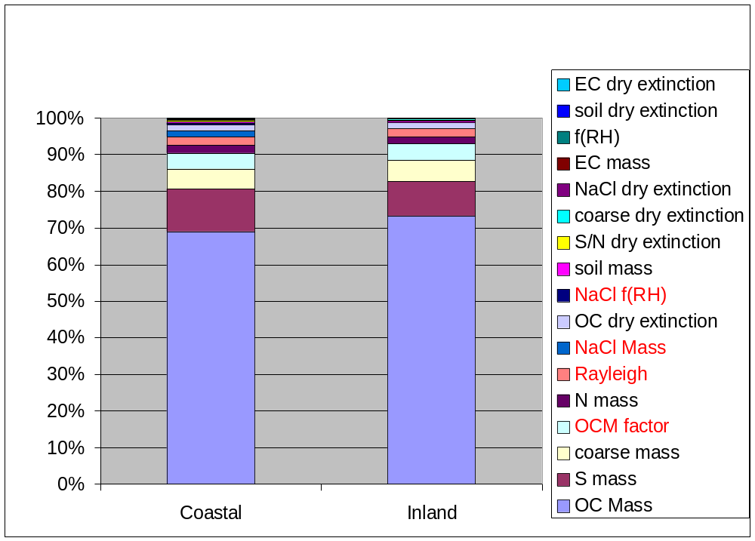
Based on this general review of uncertainties associated with the refinements and the potentially substantial effect on rate of progress slopes that could result from implementing such changes, it is appropriate to accept the default natural background visibility estimates as provided in U.S. EPA guidance. The default estimates provide a sound, nationally consistent framework on which to base the regulatory structure of the haze rule that is justified based upon the current state of scientific understanding of these issues.
Figure 2. Range of relative contribution to overall uncertainty in natural background deciview estimates (high and low extremes derived using extreme values of extinction range)

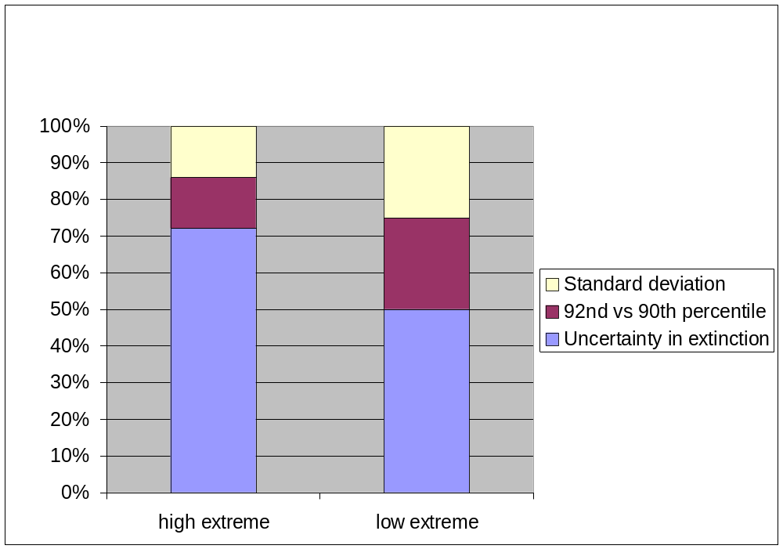
Further, EPA recommendations on potential refinements (Pitchford, personal communication, 2004) suggest that such refinements be broadly accepted by the scientific community, substantial, practical to implement and not create arbitrary inconsistencies. In addition, these recommendations request that state efforts to refine the default estimates should not side-track technical efforts on other aspects of the regional haze program. Hence, it is appropriate to adopt the default natural background conditions at present time until broad consensus on refined estimates of the individual species concentrations (in particular, organic carbon) is established.

5. Recommendation
This document reviews potential refinements to EPA guidelines for calculating natural background visibility conditions and explores how such refinements are likely to affect calculated rates of progress. Based on the currently available literature on naturally occurring fine particulate matter over the coastal and continental U.S. and a detailed analysis of the error propagation of such refinements on the resulting estimates of natural visibility conditions, changes to the default methods for calculating these conditions will not be undertaken by MANE-VU at this time.
MANE-VU recognizes the simplicity of the default approach and supports future adjustments which better reflect true natural background visibility levels as the science surrounding this issue evolves and more accurate information is available to support such changes. In particular, efforts to reduce the uncertainties associated with estimates of organic carbon, sulfate and coarse mass are most important to pursue through future research activities aimed at improving estimates of natural visibility conditions. Potential refinements investigated in this document including the addition of sea salt, revision of the organic carbon multiplier and improved understanding of the distribution of naturally occurring visibility conditions rank as a second tier set of priorities to be addressed through future research.
Based on this review, MANE-VU proposes to adopt the default estimates at this time, to actively participate in further research efforts on this topic, and to reconsider our position with respect to natural background visibility conditions as future scientific understanding warrants.

References
Ames, R. B., and Malm, W. C. (2001). Recommendations for Natural Condition Deciview
Variability: An Examination of IMPROVE Data Frequency Distributions. Proceedings (CDROM) of A&WMA/AGU Specialty Conference on Regional Haze and Global Radiation Balance -- Aerosol Measurements and Models: Closure, Reconciliation and Evaluation, Bend, Oregon, 2-5 October.

Day, Malm, Kreidenweis Aerosol Light Scattering Measurements as a Function of Relative Humidity JAWMA 50: 710-716 May 2000
Eldred, Feeney, Wakabayashi The Major Components of PM2.5 at Remote Sites across the United States V1 of AWMA Proceedings of an International Specialty Conference Jan 1998 Long Beach CA pp13-26
Haywood Ramaswamy and Soden SCIENCE V283 26Feb99 1299-1303 Tropospheric aerosol climate forcing in Clear-Sky Satellite Observations over the oceans.

Hegg, Livingston, Hobbs, Novakov and Russell JGR vol. 102 D21 P25293-303 1997 Chemical Apportionment of aerosol column optical depth off the Mid-Atlantic coast of the United States
IMPROVE, (2000), Malm, W. C., Principal Author, Spatial and Seasonal Patterns and Temporal Variability of Haze and Its Constituents in the United States: Report III. Cooperative Institute for Research in the Atmosphere, Colorado State university, Ft. Collins, CO. May.

Kumar, N. (2004). Recommendations for Natural Background Conditions and Potential Refinements. Proceedings (CDROM) of MANE-VU/MARAMA Science Meeting on Regional Haze – Organic Aerosols and Natural Background Conditions, Baltimore, MD, 27-29 January.

Lowenthal, D. H., and Kumar, N. (2003). PM2.5 Mass and Light Extinction Reconstruction in IMPROVE. Journal of the Air and Waste Management Association, Vol. 53, pp. 1109-1120.

Malm, Molenar, Eldred and Sisler Examining the relationship among atmospheric aerosols and light scattering and extinction in the Grand Canyon area JGR V101 D14 pg19251-65 1996
Malm, Day, Kreidenweis, Light Scattering Characteristics of Aerosols as a function of Relative Humidity: Part 1- A comparison of Measured Scattering and Aerosol Concentrations Using the Theoretical Models. JAWMA 50:686-700 May 2000
Malm, W. C. (2004). Recommendations for Natural Background Conditions and Potential Refinements. Proceedings (CDROM) of MANE-VU/MARAMA Science Meeting on Regional Haze – Organic Aerosols and Natural Background Conditions, Baltimore, MD, 27-29 January.

U.S. EPA (2003). Guidance for Estimating Natural Visibility Conditions under the Regional Haze Rule. EPA-454/B-03-005. September.

Taylor, J. R. (1982). An Introduction to Error Analysis, University Science Books, Oxford University Press, Mill Valley, CA.

Tombach, I., 2003. On Refining Estimates of Natural Background Light Extinction in the VISTAS Region, A report prepared for VISTAS, December 04.

Trijonis, J. C. (1990). Characterization of Natural Background Aerosol Concentrations. Appendix A in Acidic Deposition: State of Science and Technology. Report 24. Visibility: Existing and Historical Conditions -- Causes and Effects. J. C. Trijonis, lead author. National Acid Precipitation Assessment Program, Washington, DC.

Turpin, B. J., and Lim, H-J. (2001). Species Contributions to PM2.5 Mass Concentrations:
Revisiting Common Assumptions for Estimating Organic Mass. Aerosol Science and Technology,
Vol. 35, pp. 602-610.
Watson, J.G. (2002). Visibility: Science and Regulation. J. Air Waste Manag. Assoc., 52, 628-713.

